**Is Confusion Sometimes A Good Thing?**

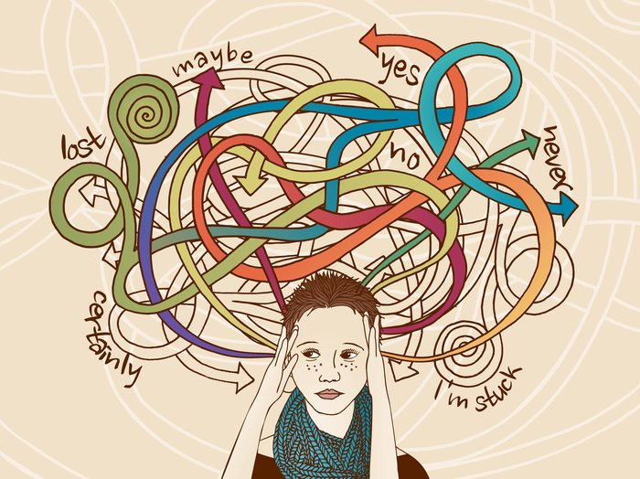

(Stormy Beginning) Confusion gets a bad rap. A textbook that confuses its readers sounds like a bad textbook. Although Teachers who confuse their students sound like bad teachers, research suggests that some of the time, confusion can actually be a good thing — an important step toward learning.( Thesis)

Consider a 2004 study in which participants learned basic computer literacy from an automated tutoring system. As they worked through the lessons, researchers coded which of several emotions they seemed to exhibit, including confusion and boredom. Analyses revealed that learners who spent a greater proportion of the lessons in a state of confusion exhibited significantly greater gains in learning. Boredom, however, was associated with lower gains in learning.

So it appears that confusion is associated with learning, at least under some conditions. But why?

One possibility is that confusion is not itself beneficial, but rather a marker that a salient cognitive process has taken place: The learner has appreciated some inconsistency or deficit in her prior beliefs. But another possibility is that confusion is itself a step toward learning — an experience that motivates the learner to reconcile an inconsistency or remedy some deficit.Supporting this stronger view, there's evidence that experiencing difficulties in learning can sometimes be desirable, leading to deeper processing and better long-term memory.

Of course, confusion isn't always a good thing. Sometimes a textbook is truly terrible, or a teacher impossible to understand. ( Dangling Subject) Being confused by something irrelevant to what you're trying to , you are unlikely to learn the content you're after. Moreover, experiencing confusion without the resources to resolve that confusion could contribute to frustration and disengagement.

In a lovely essay in the Journal of Cell Science, Martin Schwartz argues for the importance of feeling stupid in scientific research. "If we don't feel stupid," he writes, "it means we're not really trying." Like feeling stupid, feeling confused can be aversive. But it's also a signal that we're on the path to learning, and that's an outcome to embrace.( terminating Statement)

 *By :* Tania Lombrozo

Tania Lombrozo is a psychology professor at the University of California, Berkeley. She writes about psychology, cognitive science and philosophy.