**What’s the right age to get married?**

BY DONNA HUSSEY-WHYTE

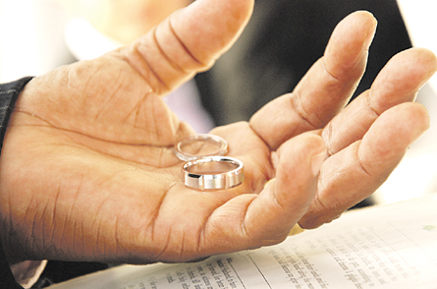

WHILE some will argue that the best time to tie the knot is when you have found Mr or Mrs Right with age not being a factor, experts swear couples have the best odds of making it for the long haul if they wait until after 25 to get hitched*.( Thesis)* And with local divorce numbers steadily rising, it is thought that after this age, couples are in a greater position to have a happy, stable marriage.

It is believed that, among other things, by 25 persons have passed the -first –love -stage ; have experienced enough of life to qualify as ‘mature 'and are supporting themselves so there’s less incentive to rush into marriage for financial security.

Forty-one year-old Robert McHugh says the mid to late 20s are in fact the opportune time to get married, noting, however, that what one should look at, at any age, is the other person’s level of maturity.

“Between 25 to 30 could be considered an ideal age because persons are more stable and mature financially, mentally and otherwise,” McHugh said. “And it gives you the opportunity to grow with your children. For instance, if you have a child at 27, when that child reaches 20 you’ll still be in your 40s. And if the cycle is followed, grandchildren will be a joy as you will be able to be active with them,” he explained. “You can’t run up and down when arthritis begin to box you left right and centre.”

Below are the views of other persons we polled.

**Dean Munroe, 36, sales manager:**

Age 35 and over for a man. He would have been experienced by then. By this age most men would have done a lot or at least most of their explorations and would be coming into their own personally and professionally. Therefore, they would be ready for the commitment of marriage. It can be anytime after 30 for women as they do mature faster than men.

**Nicole Warren, 30, communications manager:**

At 25. Because hopefully by that time they would have completed tertiary education and be more career focused. Now they would be more mature and in a better position to take on living with someone in a stable environment, and for the woman, she would now be able to take on motherhood.

All in all, age has nothing to do with marriage. As long as the person reaches the age of consent and honestly thinks that the person they find is the right person, then that’s enough. Age is just a number and everybody matures at different levels so it’s not safe to put a time or limit to it.

*Comment :*

*This is one of those rare cases in which the introduction starts off with the thesis statement.*